1.B)

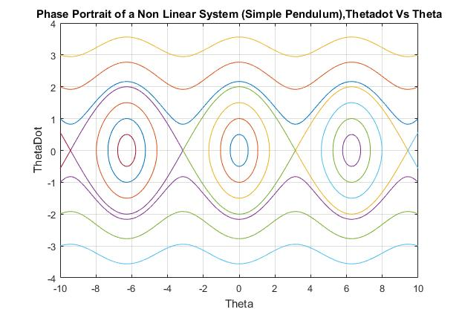

**Figure 1**: Phase Plane Portrait of the Non Linear System (Simple Pendulum)

2.A)

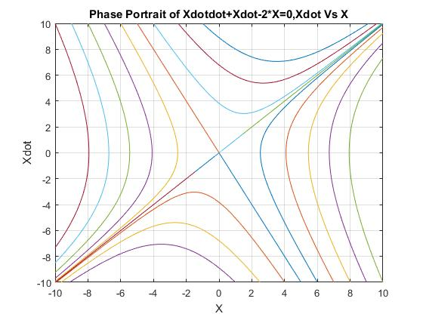

**Figure 2.** Phase Plane Portrait of the Given System

2.C)

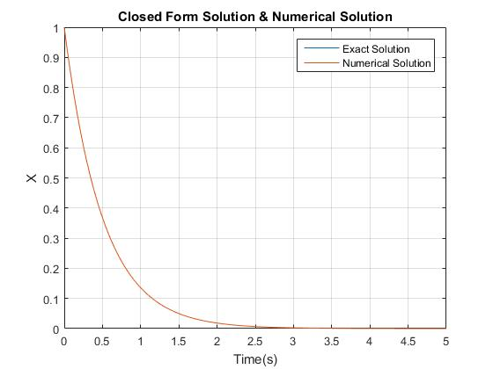

**Figure 3:** Closed Form and Numerical Solution

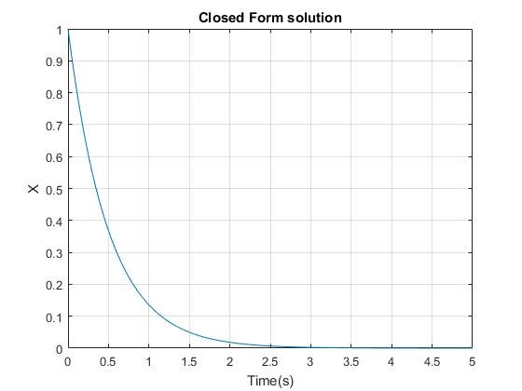

**Figure 4:** Closed Form Exact Solution

From Figure 3 and 4, it can be inferred that both the numerical and closed form exact solution are exactly the same. The closed form solution perfectly superimpose on to the numerical solution as shown in figure 3. Form the above the graphs it can also be noted that the system is stable for the given initial conditions, as the system reaches zero at steady state as shown above.

1.D)

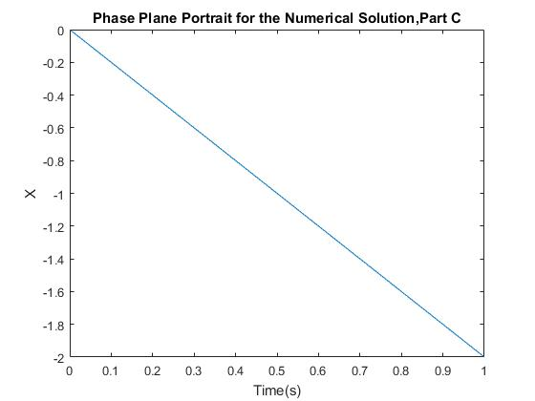

**Figure 5:** Phase Plane Portrait for the System with IC’s, x (0) = 1 and xdot (0 )= -2

**SIMULINK MODELS**

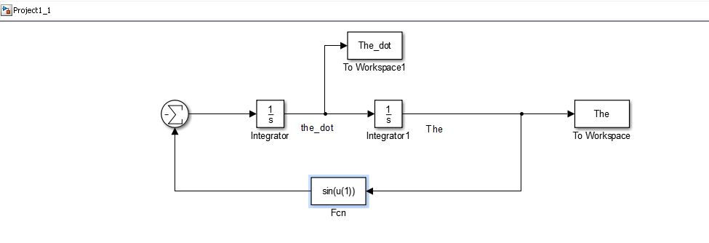

**Figure 6:** Simulink Model for Question 1 (Simple Pendulum)

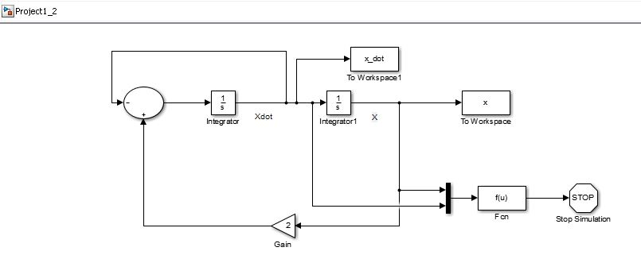

**Figure 7:** Simulink Model for Question 2

**MATLAB CODE**

%% Problem 1

%%Phase Plane Portrait and equlibirum points of a simple pendulum

%Equilibrium Point at 0

%define the 1st intial conditions (First Concentric circle at 0)

x0=0;

x_dot0=0.5;

%call the simulation

sim('Project1_1')

%save the data

x1=The;

x_dot1=The_dot;

%define the 2nd intial conditions (Second Concentric cirlce at 0)

x0=0;

x_dot0=1;

%call the simulation

sim('Project1_1')

%save the data

x2=The;

x_dot2=The_dot;

%define the 3rd intial conditions (Third Concentric circle at 0)

x0=0;

x_dot0=1.5;

%call the simulation

sim('Project1_1')

%save the data

x3=The;

x_dot3=The_dot;

%Equilibrium Point at 6.28

%define the 4th intial conditions (First Concentric circle at 6.28)

x0=6.28;

x_dot0=0.5;

%call the simulation

sim('Project1_1')

%save the data

x4=The;

x_dot4=The_dot;

%define the 5th intial conditions (Second Concentric circle at 6.28)

x0=6.28;

x_dot0=1;

%call the simulation

sim('Project1_1')

%save the data

x5=The;

x_dot5=The_dot;

%define the 6th intial conditions (Third Concentric circle at 6.28)

x0=6.28;

x_dot0=1.5;

%call the simulation

sim('Project1_1')

%save the data

x6=The;

x_dot6=The_dot;

%Equilibrium Point at -6.28

%define the 7th intial conditions (First Concentric circle at -6.28)

x0=-6.28;

x_dot0=0.5;

%call the simulation

sim('Project1_1')

%save the data

x7=The;

x_dot7=The_dot;

%define the 8th intial conditions (Second Concentric circle at -6.5)

x0=-6.28;

x_dot0=1;

%call the simulation

sim('Project1_1')

%save the data

x8=The;

x_dot8=The_dot;

%define the 9th intial conditions (Third Concentric circle at -6.5)

x0=-6.28;

x_dot0=1.5;

%call the simulation

sim('Project1_1')

%save the data

x9=The;

x_dot9=The_dot;

%Equilibrium Points at 3.14 & 9.4248

%define the 10th intial conditions (First Right curve)

x0=3.145;

x_dot0=0;

%call the simulation

sim('Project1_1')

%save the data

x10=The;

x_dot10=The_dot;

%Equilibrium Points at -9.4248 & -3.14

%define the 11th intial conditions (First Left curve)

x0=-3.145;

x_dot0=0;

%call the simulation

sim('Project1_1')

%save the data

x11=The;

x_dot11=The_dot;

%Equilibrium Points at -3.14 & 3.14

%define the 12th intial conditions (First Centre Curve)

x0=3.14;

x_dot0=0;

%call the simulation

sim('Project1_1')

%save the data

x12=The;

x_dot12=The_dot;

%Equilibrium Points at 9.4248 & 12.56

%define the 13th intial conditions (Second Right curve)

x0=9.4248;

x_dot0=0;

%call the simulation

sim('Project1_1')

%save the data

x13=The;

x_dot13=The_dot;

%Equilibrium Points at -12.56 & -9.4248

%define the 14th intial conditions (Second left curve)

x0=-9.4248;

x_dot0=0;

%call the simulation

sim('Project1_1')

%save the data

x14=The;

x_dot14=The_dot;

%Upper Wave Trajectories

%define the 15th intial conditions (First Top Wave)

x0=-10;

x_dot0=1;

%call the simulation

sim('Project1_1')

%save the data

x15=The;

x_dot15=The_dot;

%define the 16th intial conditions (Second Top Wave)

x0=-10;

x_dot0=2;

%call the simulation

sim('Project1_1')

%save the data

x16=The;

x_dot16=The_dot;

%define the 17th intial conditions (Third Top Wave)

x0=-10;

x_dot0=3;

%call the simulation

sim('Project1_1')

%save the data

x17=The;

x_dot17=The_dot;

%Bottom Wave Trajectories

%define the 18th intial conditions (First Bottom Wave)

x0=10;

x_dot0=-1;

%call the simulation

sim('Project1_1')

%save the data

x18=The;

x_dot18=The_dot;

%define the 19th intial conditions (Second Bottom Wave)

x0=10;

x_dot0=-2;

%call the simulation

sim('Project1_1')

%save the data

x19=The;

x_dot19=The_dot;

%define the 20th intial conditions (Third Bottom Wave)

x0=10;

x_dot0=-3;

%call the simulation

sim('Project1_1')

%save the data

x20=The;

x_dot20=The_dot;

%Plot the Phase Plane Portrait

figure(1),plot(x1,x_dot1,x2,x_dot2,x3,x_dot3,x4,x_dot4,x5,x_dot5,x6,x_dot6,x7,x_dot7,x8,x_dot8,x9,x_dot9,x10,x_dot10,x11,x_dot11,x12,x_dot12,x13,x_dot13,x14,x_dot14,x15,x_dot15,x16,x_dot16,x17,x_dot17,x18,x_dot18,x19,x_dot19,x20,x_dot20)

grid on

axis([-10 10 -4 4]);

title('Phase Portrait of a Non Linear System (Simple Pendulum),Thetadot Vs Theta');

xlabel('Theta'),ylabel('ThetaDot');

%%Problem 2

%%Part A, Phase Plane Plot of the System

%First Diagonal Line

%define the 1st inital conditions (bottom diagonal line)

x_dot0=-10;

x0=5;

%run the simualtion

sim('Project1_2')

%save the data

x1=x;

x_dot1=x_dot;

%define the 2nd inital conditions (Upper diagonal line)

x_dot0=10;

x0=-5;

%run the simualtion

sim('Project1_2')

%save the data

x2=x;

x_dot2=x_dot;

%Curves in the Upper Left Quadrant

%define the 3rd inital conditions (Upper left 1st curve)

x_dot0=10;

x0=-6;

%run the simualtion

sim('Project1_2')

%save the data

x3=x;

x_dot3=x_dot;

%define the 4th inital conditions (Upper left 2nd curve)

x_dot0=10;

x0=-7;

%run the simualtion

sim('Project1_2')

%save the data

x4=x;

x_dot4=x_dot;

%define the 5th inital conditions (Upper left 3rd curve)

x_dot0=10;

x0=-8;

%run the simualtion

sim('Project1_2')

%save the data

x5=x;

x_dot5=x_dot;

%define the 6th inital conditions (Upper left 4th curve)

x_dot0=10;

x0=-9;

%run the simualtion

sim('Project1_2')

%save the data

x6=x;

x_dot6=x_dot;

%define the 7th inital conditions (Upper left 5th curve)

x_dot0=10;

x0=-10;

%run the simualtion

sim('Project1_2')

%save the data

x7=x;

x_dot7=x_dot;

%Curves in the Bottom Left Quadrant

%define the 8th inital conditions (bottom left 1st curve)

x_dot0=-10;

x0=6;

%run the simualtion

sim('Project1_2')

%save the data

x8=x;

x_dot8=x_dot;

%define the 9th inital conditions (bottom left 2nd curve)

x_dot0=-10;

x0=7;

%run the simualtion

sim('Project1_2')

%save the data

x9=x;

x_dot9=x_dot;

%define the 10th inital conditions (bottom left 3rd curve)

x_dot0=-10;

x0=8;

%run the simualtion

sim('Project1_2')

%save the data

x10=x;

x_dot10=x_dot;

%define the 11th inital conditions (bottom left 4th curve)

x_dot0=-10;

x0=9;

%run the simualtion

sim('Project1_2')

%save the data

x11=x;

x_dot11=x_dot;

%define the 12th inital conditions (bottom left 5th curve)

x_dot0=-10;

x0=10;

%run the simualtion

sim('Project1_2')

%save the data

x12=x;

x_dot12=x_dot;

%Curves in the Top Right Quadrant

%define the 13th inital conditions (Top right 1st curve)

x_dot0=10;

x0=-4;

%run the simualtion

sim('Project1_2')

%save the data

x13=x;

x_dot13=x_dot;

%define the 14th inital conditions (Top right 2nd curve)

x_dot0=10;

x0=-2.5;

%run the simualtion

sim('Project1_2')

%save the data

x14=x;

x_dot14=x_dot;

%define the 15th inital conditions (Top right 3rd curve)

x_dot0=10;

x0=-1;

%run the simualtion

sim('Project1_2')

%save the data

x15=x;

x_dot15=x_dot;

%Curves in the Bottom Right Quadrant

%define the 16th inital conditions (Bottom Right 1st curve)

x_dot0=-10;

x0=4;

%run the simualtion

sim('Project1_2')

%save the data

x16=x;

x_dot16=x_dot;

%define the 17th inital conditions (Bottom Right 2nd curve)

x_dot0=-10;

x0=2.5;

%run the simualtion

sim('Project1_2')

%save the data

x17=x;

x_dot17=x_dot;

%define the 18th inital conditions (Bottom Right 3rd curve)

x_dot0=-10;

x0=1;

%run the simualtion

sim('Project1_2')

%save the data

x18=x;

x_dot18=x_dot;

%Second Diagonal Line

%define the 19th inital conditions (right diagonal line)

x_dot0=1;

x0=1;

%run the simualtion

sim('Project1_2')

%save the data

x19=x;

x_dot19=x_dot;

%define the 20th inital conditions (right diagonal line)

x_dot0=0.01;

x0=0.01;

%run the simualtion

sim('Project1_2')

%save the data

x20=x;

x_dot20=x_dot;

%define the 21th inital conditions (left diagonal line)

x_dot0=-1;

x0=-1;

%run the simualtion

sim('Project1_2')

%save the data

x21=x;

x_dot21=x_dot;

%define the 22nd inital conditions (left diagonal line)

x_dot0=-0.01;

x0=-0.01;

%run the simualtion

sim('Project1_2')

%save the data

x22=x;

x_dot22=x_dot;

%Plot the Phase Plane Portrait

figure(2),plot(x1,x_dot1,x2,x_dot2,x3,x_dot3,x4,x_dot4,x5,x_dot5,x6,x_dot6,x7,x_dot7,x8,x_dot8,x9,x_dot9,x10,x_dot10,x11,x_dot11,x12,x_dot12,x13,x_dot13,x14,x_dot14,x15,x_dot15,x16,x_dot16,x17,x_dot17,x18,x_dot18,x19,x_dot19,x20,x_dot20,x21,x_dot21,x22,x_dot22)

grid on

axis([-10 10 -10 10])

title('Phase Portrait of Xdotdot+Xdot-2*X=0,Xdot Vs X');

xlabel('X'),ylabel('Xdot');

%%Part C, Comparing the numerical solution and the Closed-form Exact Solution

%Define the initial conditions

x0=1;

x_dot0=-2;

%call the simulation

sim('Project1_2')

%save the data for the given inital conditions

xc=x;

xc_dot=x_dot;

%define the closed form exact solution obtained by hand calculations

y=exp(-2*tout);

%plot the closed form exact solution and numerical solution

figure(3), plot(tout,y,tout,xc)

grid on;

title('Closed Form solution Vs Numerical Solution');

xlabel('Time(s)'),ylabel('X');

legend('Exact Solution','Numerical Solution')

%Plot the closed form exact solution

figure(4), plot(tout,y)

grid on;

title('Closed Form solution');

xlabel('Time(s)'),ylabel('X');

%%Part D, Is the Sytsem Stable for the above IC's

%Phase Plane Portrait for the given condition for the Numerical Solution

figure(5), plot(xc,xc_dot)

title('Phase Plane Portrait for the Numerical Solution,Part C');

xlabel('Time(s)'),ylabel('X');